bmz it solutions

Xisd6319

Bongumusa Cele - St10127074 (team leader)

mthokozisi luthuli - st10127546

zwelibanzi chauke - st10127149

Work Integrated Learning 3 POE

2022

Table of Contents

Project Plan 3

Introduction 3

Milestones and Deliverables 4

Work Breakdown Structure 5

Project Schedules 10

Gantt Chart 10

PERT Chart 11

Risk Management 12

Technical Feasibility Issues 13

Economic Feasibility Issues 14

Team Members 16

Project Charter 16

Requirements Analysis 17

Problem Domain (System Analysis) 17

Solution Domain (Functional requirements specs and UML Use Cases) 18

Logical System Model 19

Class Diagrams 20

System Design 21

Logical Architectural Design 21

High Level Architectural Design 21

Low Level Architectural Design 22

Interactions with the User 23

Registration info 23

Registration Info GUI 23

Login Info 23

Login Info GUI 23

Set An Appointment Info 24

Set An Appointment Info GUI 24

Contact Us Info 24

Contact Us Info GUI 24

Place Order Info 25

Place Order Info GUI 25

Add Products Info 25

Add Products Info GUI 25

Database Design 26

Database Tables 26

ERD Design 27

# Project Plan

## Introduction

The company (Discount Audio and Motor Spares) is a newly established business as it has only been in business for only 2 months. The business needs a mobile application and web application for its customers to use to shop for audio accessories and various motor spares. The mobile application and website will also attract new customers from anywhere in South Africa.

The goal or outcome of this project is to develop a mobile application and website that allows customers to create accounts, view various motor spares and audio accessories available to buy, book appointments for car audio, alarm systems and rims & tyres installations, view other services provided, purchase products, provide customer feedback (reviews) and search for a product the want. The data captured will be stored in an appropriate Database Management System (DBMS).

The budget estimated for this project is ‘’R160 000’’, this budget will cover the required costs for software, hardware and labour that will be used during the development of the project.

Some of the possible risks identified are the complete functionality and security of the databases used to store Discount Audio and Motor Spares’s data. Due to the large amount of customer data that needs to be stored, server maintenance costs can be higher than expected if the business chooses to officially launch the website and mobile application.

If the project is a success, Discount Audio and Motor Spares will receive an influx of new clientele from all over the country, see a boost in advertisement and an increase in their revenues.

## Milestones and Deliverables

|  |  |  |
| --- | --- | --- |
| **Milestones** | **Completion Date** | **Deliverables** |
| Create a baseline project plan | August 12, 2022 | Project charter signed and project plan document submitted |
| Determine functional and non-functional requirements | August 19, 2022 | Requirements analysis document completed and submitted |
| Design Mobile app and website’s architecture and database | September 20, 2022 | ERDs and Database tables completed. Input interactions or graphical user interface designs done. |
| Develop database | September 23, 2022 | Database tables and structure |
| Develop Code for website | October 21, 2022 | Source code for website |
| Develop Code for mobile application | October 24, 2022 | Source code for mobile application |
| Test Website | November 11, 2022 | Bugs and defects for website identified and fixed |
| Test Mobile application | November 15, 2022 | Bugs and defects for mobile application identified and fixed |
| Present and demonstrate Prototype | November 18, 2022 | Fully functional prototypes |
| Present and demonstrate Final project | November 21, 2022 | Presentation of website and mobile app |
| Both software reviewed | Final Week | Website and mobile application maintenance |

## Work Breakdown Structure

|  |  |  |  |  |  |
| --- | --- | --- | --- | --- | --- |
| **Task Name** | **Description of task** | **Team member**  **responsible for**  **the task** | **Duration of the**  **task in days** | **Predecessor Task** | **Resources needed for task** |
| **1.Initiation** | People are assigned to a team of 3 members to begin the review of project case study. | Group | 10 |  | PCs, internet access, Zoom, MS Word |
| **1.1 Define project goal** | Members of the team decide on a team leader and secretary by voting for a candidate | Group | 1 |  | Smart phone |
| **1.2 Create the project case** | Identify the current issue of Discount Audio and Motor Spares manual system and daily operations of the business. | Bongumusa | 3 | 1.1 | PCs, internet access, Zoom, MS Word |
| **1.3 identify list of stakeholders** | Decide what functions can be included in the system. Identify stakeholders within and outside of Discount Audio and Motor Spares. | Group | 3 | 1.2 | PCs, internet access, Zoom, MS Word |
| **1.4 Develop high-level project objective and constraints** | List all possible components needed for inputting, processing, and outputting data | Mthokozisi | 4 | 1.3 | PCs, internet access, Zoom, MS Word |
| **2.Planning** | Analyze and identify criteria project scope, outcome | Group | 20 | 1 | PCs, internet access, Zoom, MS Word |
| **2.1 Develop and determine scope** |  | Zwelibanzi | 2 |  | PCs, internet access, Zoom, MS Word |
| **2.2 Gather the project quality requirements** | Assign tasks and responsibilities to team members and allocate time for each task and sub task. | Group | 3 | 2.1 | PCs, internet access, MS Word |
| **2.3 Baselined budget of the Project** | Make a project schedule and GHAN chart with MS Project | Mthokozisi | 1 | 2.2 | PCs, internet access, MS Project |
| **2.4 The projects schedule** | Project has been planned | Zwelibanzi | 3 | 2.3 | PCs, internet access, MS Project |
| **2.5 Identify risk of the project** | View possible risks that may occur | Group | 4 | 2.4 | PCs, internet access, MS Project |
| **2.6 Identify general execution** | Identify the scope and objective of the project | Zwelibanzi | 3 | 2.5 | PCs, internet access, MS Project |
| **2.7 Maintain integration** | See how components of the systems will be integrated | Bongumusa | 5 | 2.6 | PCs, internet access, MS Project |
| **3. EXECUTION** | Coding for front-end, back end and firmware components | Group | 35 | 2 | PCs, internet access, Android Studio, Visual Studio, Wampserver, Firebase |
| **3.1. Draft application** | Brief members on the approach to code the system components. Delegate portions of system to a pair of team members to code. | Group | 4 |  | PCs, internet access, Android Studio, Visual Studio, Wampserver, Firebase |
| **3.2. Design application** | Write code for the application pages, menus, buttons etc. | Zwelibanzi | 7 | 3.1 | PCs, internet access, Android Studio, Visual Studio, Wampserver, Firebase |
| **3.3 Add components** | Write code for user-interactive dialogs such as prompting user for input and ensuring the correct data type is entered. | Bongumusa | 8 | 3.2 | PCs, internet access, Android Studio, Visual Studio, Wampserver, Firebase |
| **3.4. Add features** | Write code for system modules for calculating, sorting, and modifying data. | Bongumusa | 6 | 3.3 | PCs, internet access, Android Studio, Visual Studio, Wampserver, Firebase |
| **3.5. managing the work of the project** | Create database with tables to store the data that was entered from user-input. Write code to connect database to website and local host. | Group | 5 | 3.4 | PCs, internet access, Android Studio, Visual Studio, Wampserver, Firebase |
| **3.6. manage and mitigate risks that threaten project success** | Continue working on the project | Mthokozisi | 2 | 3.5 | PCs, internet access, Android Studio, Visual Studio, Wampserver, Firebase |
| **3.7. ensure that external stakeholders are engaged appropriately and that their expectations are being met** | Engage with stakeholders and keep on updating them about system improvements or new developments. | Zwelibanzi | 3 | 3.6 | PCs, internet access, Android Studio, Visual Studio, Wampserver, Firebase |
| **4. TESTING** | Test the systems for bugs and defects | Group | 16 | 3 | PCs, internet access, Android Studio, Visual Studio, Wampserver, Firebase |
| **4.1 Test emulator** | Do unit testing | Zwelibanzi | 2 |  | PCs, internet access, Android Studio, Visual Studio, Wampserver, Firebase |
| **4.2 Test functionality** | Do functional testing | Bongumusa | 4 | 4.1 | PCs, internet access, Android Studio, Visual Studio, Wampserver, Firebase |
| **4.3 Test if the application runs on an actual device** | Perform integrational testing | Mthokozisi | 5 | 4.2 | PCs, internet access, Android Studio, Visual Studio, Wampserver, Firebase |
| **4.4 Check if the application has bugs** | Run end-to-end tests | Bongumusa | 4 | 4.3 | PCs, internet access, Android Studio, Visual Studio, Wampserver, Firebase |
| **5. Presentation** | Organize a presentation of the systems while demonstrating how it works. | Group | 4 | 4 | PCs, internet access, MS PowerPoint |
| **5.1. implement the prototype** | Prepare the systems to be released and used commercially by clients | Group | 2 |  | PCs, internet access, MS PowerPoint |
| **5.2. Demonstrate working prototype** | Present the system to Discount Audio and Motor Spares executives as a final product. | Group | 2 | 5.1 | PCs, internet access, MS PowerPoint |

## Project Schedules

## Gantt Chart



## PERT Chart



## Risk Management

|  |  |  |  |
| --- | --- | --- | --- |
| **Risk Area** | **Occurrence H/L/M** | **Impact H/L/M** | **Risk Response** |
| System could crash due to high traffic of customers. | Low | High | Increase database capacity. |
| Loss of customer data or information. | Medium | Medium | Backup customer data and information in cloud storage. |
| Project completion delayed. | Low | Medium | Organize days when the team works overtime to make up for the delayed days. |
| Software incompatibility. | Low | Medium | Identify other open-source software that can be used. |
| Personal Laptop or hardware damage. | High | Medium | Use the school’s computers or Azure virtual machines provide by the school. |
| Project files loss. | Medium | High | Create backup for all project files and documents. Store the files and documents on external storage devices or on cloud storage. |

## Technical Feasibility Issues

|  |  |  |
| --- | --- | --- |
| **Hardware Resources** | **Availability of the resource (yes/no)** | **Method of acquiring resource if not available** |
| PCs (laptop, desktop) | Yes | Resource Available |
| Smart phone | Yes | Resource Available |
| Hard drive | Yes | Resource Available |
| Wi-Fi router (internet) | No | Use the campus’s network like RC Braamfontein campus Wi-Fi. |

|  |  |  |
| --- | --- | --- |
| **Software Resources** | **Availability of the resource (yes/no)** | **Method of acquiring resource if not available** |
| Microsoft Office (Word, Project, Power Point) | Yes | Resource Available |
| Web browser (Microsoft Edge, Chrome) | Yes | Resource Available |
| Android Studio | Yes | Resource Available |
| Visual Studio Code | Yes | Resource Available |
| Wampserver | No | Use the one provided by the school on a virtual machine or on campus. |

## Economic Feasibility Issues

|  |  |  |  |  |
| --- | --- | --- | --- | --- |
| **Name of task** | **Team member responsible for task** | **Time allocated to complete task** | **Tariff per**  **team member**  **in Rand per**  **hour** | **Cost per**  **Task**  **(time * tariff)** |
| Determine scope and key role players | Zwelibanzi | 42 hours | 120 | 5040 |
| Complete Work Breakdown Structure | Mthokozisi | 42 hours | 120 | 5040 |
| Project Schedule | Bongumusa | 42 hours | 120 | 5040 |
| Review requirements for analysis criteria | Mthokozisi | 24 hours | 120 | 2880 |
| Determine functional requirements | Bongumusa | 40 hours | 120 | 4800 |
| Develop Use-Case Diagrams | Zwelibanzi | 38 hours | 120 | 4560 |
| Develop logical system model | Bongumusa | 38 hours | 120 | 4560 |
| Design the application architecture | Zwelibanzi | 74 hours | 120 | 8880 |
| Design GUI components | Mthokozisi | 74 hours | 120 | 8880 |
| Develop code for input controls | Bongumusa | 74 hours | 120 | 8880 |
| Develop code for program modules | Mthokozisi | 74 hours | 120 | 8880 |
| Develop database using a DBMS | Mthokozisi | 74 hours | 120 | 8880 |
| Populate the database using real data | Zwelibanzi | 74 hours | 120 | 8880 |
| Verify and test the system | Bongumusa | 74 hours | 120 | 8880 |
| Develop user support | Mthokozisi | 74 hours | 120 | 8880 |
| implement the prototype | Zwelibanzi | 224 hours | 120 | 26880 |
| Demonstrate working prototype | Zwelibanzi | 224 hours | 120 | 26880 |
| **Total budget for project** | | | | **R156720** |

## Team Members

**Mthokozisi Luthuli - ST10127546 - (Group 1)**



**Zwelibanzi Chauke - ST10127149 - (Group 2)**



**Bongumusa Cele - ST10127074 (Group Leader) - (Group 1)**



## Project Charter



# Requirements Analysis

## 

## Problem Domain (System Analysis)

Discount Audio and Motors Spares is a newly established business which offers and provides services related to vehicles. Since the business was just established two months ago, it does not have a huge clientele and so it needs to attract new customers to sell its vehicle audio products, accessories, alarm systems, motor spares and etc. at an affordable price. Another problem the business is facing is that the shop is currently located in Alberton and this becomes a problem due to the distance certain customers have to travel to get the shop location. The app and website will not only help customers shop for car parts and be able to book various vehicle services online but also attract a new clientele from all around the country.

The website and mobile application should allow clients or users to register for an account, once they have registered, they must login into the systems using their registered credentials. After logging in, they will be able to view products available for sale, add desired items to cart, search for products they are looking for specifically, complete their orders and lastly be able to book for appointments for different kinds of car services. There will also be an admin page where the system’s administrator will be able to view orders, bookings, enquiries, add products to store and also update prices.

## Solution Domain (Functional requirements specs and UML Use Cases)

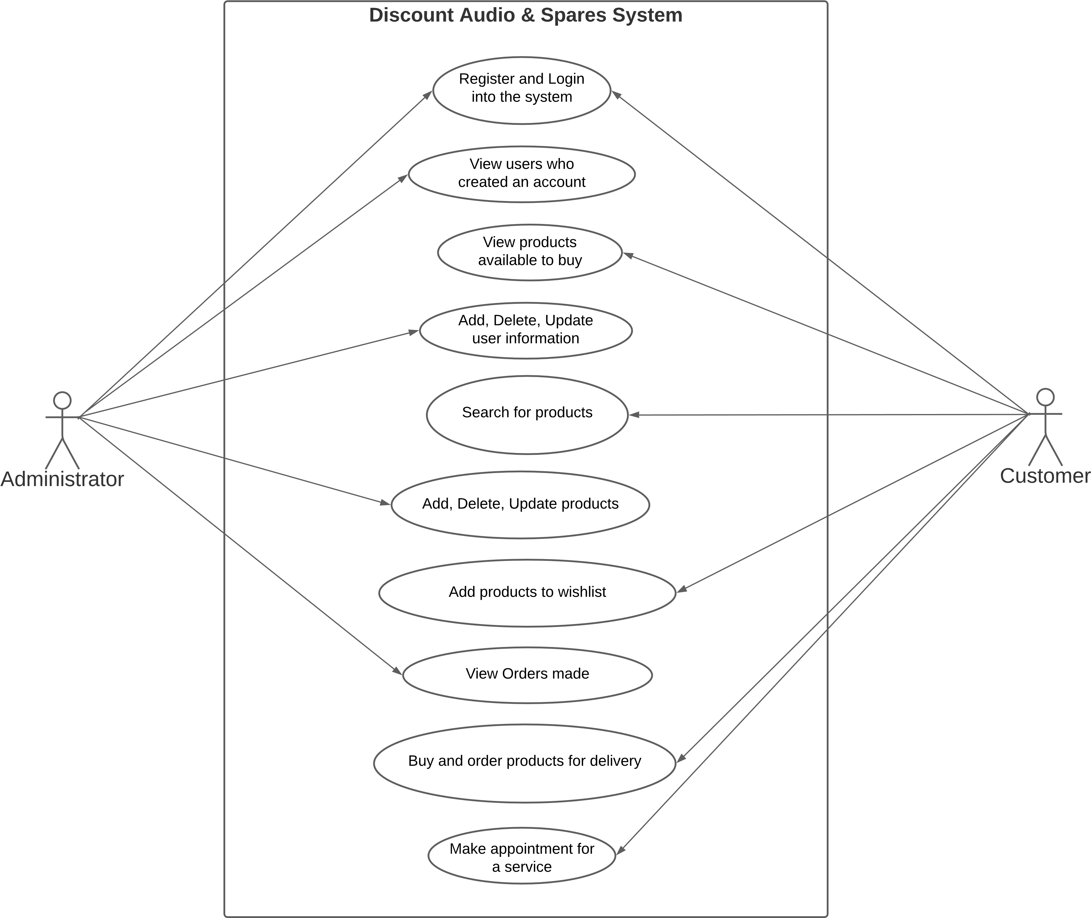

## Logical System Model

|  |  |  |  |
| --- | --- | --- | --- |
| GUI | | System Process (Method) | Entity Relationship (Table) |
| Input | **Output** |
| Enter user credentials | No Output | Register new user | Users Table |
| Enter login details | No Output | Login user to the system | Users table |
| Enter bookings details | No Output | Record new appointment | Bookings table |
| No Input | Products up for sale | Display products available for sale | Products table |
| Enter product name | Product searched by the user | Search for desired product | Products table |
| No Input | Total Price | Calculate total amount of ordered products | Orders table |
| No Input | No Output | Count number of products bought | Orders table |
| No Input | Daily/weekly/monthly appointment report | Display appointment booking details to the user | Bookings table |
| No Input | User invoice statements | Display all order information for the user | Orders table |
| Enter product information | No Output | Add, Delete, Update products | Products table |

## Class Diagrams

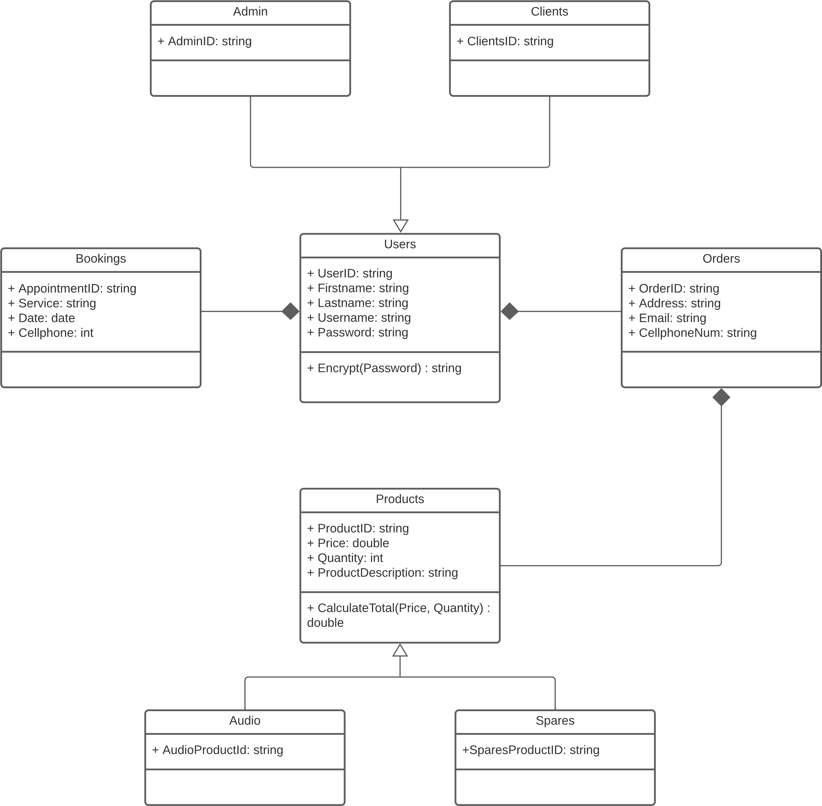

# System Design

## Logical Architectural Design

## High Level Architectural Design

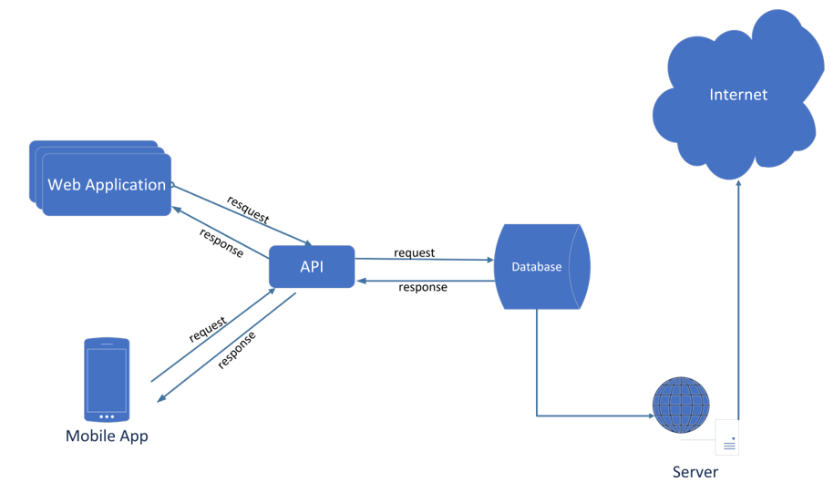

## Low Level Architectural Design



## Interactions with the User

## Registration info

|  |
| --- |
| Inputs |
| First Name |
| Surname |
| Email |
| Password |

## Registration Info GUI

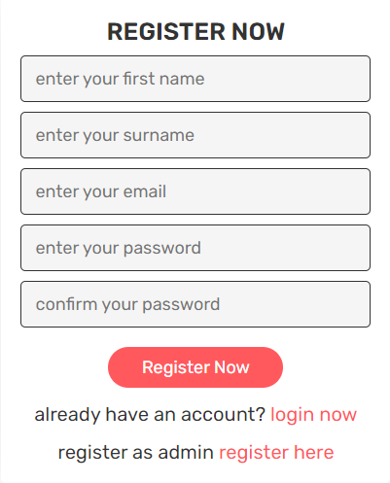

## Login Info

|  |
| --- |
| Inputs |
| Username (Email) |
| Password |

## Login Info GUI

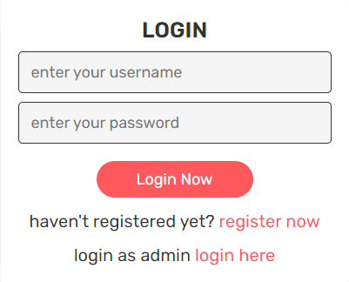

## Set An Appointment Info

|  |
| --- |
| Inputs |
| First Name |
| Email |
| Date |
| Time |
| Service Type |

## Set An Appointment Info GUI

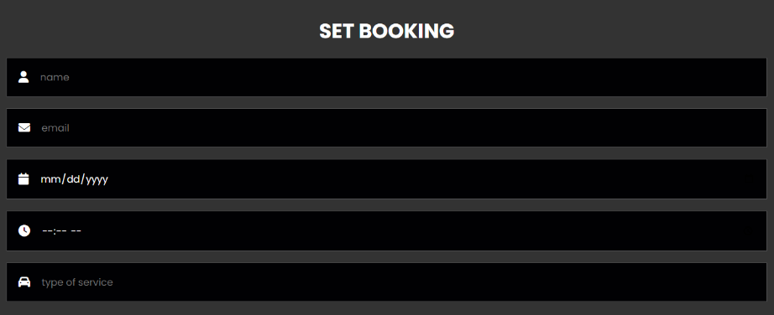

## Contact Us Info

|  |
| --- |
| Inputs |
| First Name |
| Email |
| Number |
| Enquiry |

## Contact Us Info GUI

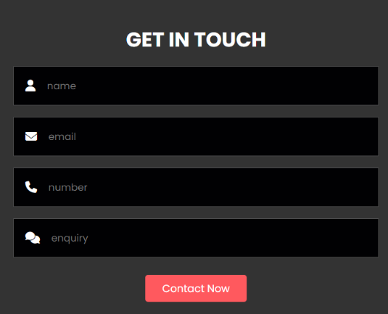

## Place Order Info

|  |
| --- |
| Inputs |
| First Name |
| Number |
| Email |
| Payment Method |
| Address |
| Province |
| Postal Code |

## Place Order Info GUI

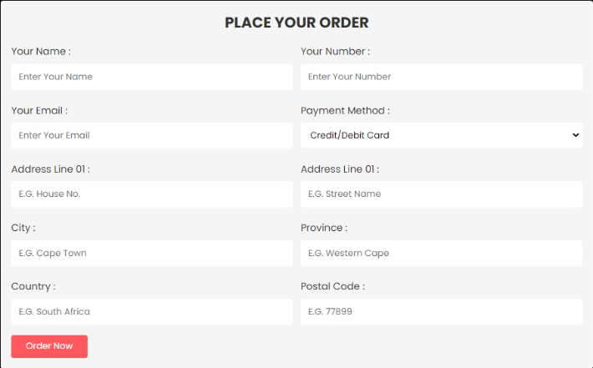

## Add Products Info

|  |
| --- |
| Inputs |
| Product Name |
| Product Price |
| Image |

## Add Products Info GUI

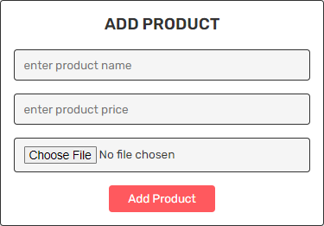

## Database Design

## Database Tables

Users

|  |
| --- |
| Attributes |
| UserID [Primary Key] |
| FirstName |
| LastName |
| Email |
| Password |

Products

|  |
| --- |
| Attributes |
| ProductID [Primary Key] |
| ProductName |
| Price |
| Category |
| Image |

Orders

|  |
| --- |
| Attributes |
| OrderID [Primary Key] |
| UserID [Foreign Key] |
| ProductID [Foreign Key] |
| Quantity |
| TotalPrice |
| DeliveryAddress |

Bookings

|  |
| --- |
| Attributes |
| BookingID [Primary Key] |
| Date |
| Time |
| Service |
| CellphoneNumber |
| Email |

Messages

|  |
| --- |
| Attributes |
| MessageID [Primary Key] |
| UserID [Foreign Key] |
| Number |
| Email |
| Message |

## ERD Design

